IT SERVICE TICKETING

1. Count the total number of tickets raised in each month:

select monthname(it_ticketing.Date_Opened) as Ticket_Month,count(it_ticketing.Ticket_ID) as Total_Ticket from it_ticketing

group by monthname(it_ticketing.Date_Opened)

order by Total_Ticket desc;

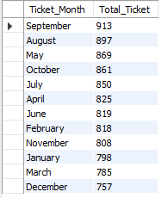

1. Top 3 most common issue types:

select it_ticketing.Issue_Type,count(it_ticketing.Ticket_ID) as Total_Ticket from it_ticketing

group by it_ticketing.Issue_Type

Order by Total_Ticket desc

limit 3;

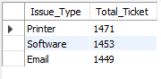

1. Tickets where SLA was breached:

select it_ticketing.Ticket_ID, it_ticketing.SLA_Hours, it_ticketing.Actual_Resolution_Hours,

row_number() over(order by it_ticketing.Ticket_ID)as Total_SLA_Breach

from it_ticketing

where it_ticketing.Actual_Resolution_Hours > it_ticketing.SLA_Hours;

1. escalated tickets by region:

select it_ticketing.Region,

count(case

when it_ticketing.`Status` = 'Escalated' then 'Attention' end) as Total_Escalated_Ticket from it_ticketing

group by it_ticketing.Region;

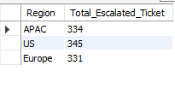

1. Average resolution time by priority:

select it_ticketing.Priority,cast(avg(it_ticketing.Actual_Resolution_Hours) as decimal(10,0)) as Avg_Resolution_Time from it_ticketing

group by it_ticketing.Priority;

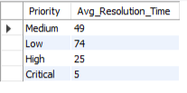

1. Top 10 clients with the most SLA breaches:

select it_ticketing.`Client`,

count(

case when it_ticketing.Actual_Resolution_Hours > it_ticketing.SLA_Hours then 'Breached' end) as Total_Breached from it_ticketing

group by it_ticketing.`Client`

order by Total_Breached desc

limit 10;

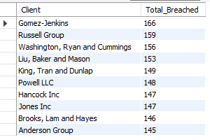

1. Average satisfaction scores for breached vs met SLAs:

select cast(avg(it_ticketing.Client_Satisfaction_Score) as decimal(10,1)) as Avg_Satisfaction_Score_Not_Breach,(select cast(avg(it_ticketing.Client_Satisfaction_Score) as decimal(10,1)) from it_ticketing

where it_ticketing.Actual_Resolution_Hours > it_ticketing.SLA_Hours) as Avg_Satisfaction_Score_Breach from it_ticketing

where (it_ticketing.Actual_Resolution_Hours < it_ticketing.SLA_Hours) or (it_ticketing.Actual_Resolution_Hours = it_ticketing.SLA_Hours);



1. Rank technicians by number of tickets resolved:

with cte as

(

select it_ticketing.Technician, it_ticketing.`Status`,count(it_ticketing.`Status`) as Total_Resolved_Ticket from it_ticketing

where it_ticketing.`Status` = 'Resolved'

group by it_ticketing.Technician, it_ticketing.`Status`

)

select * ,

rank() over (order by cte.Total_Resolved_Ticket desc) as Ranking from cte;

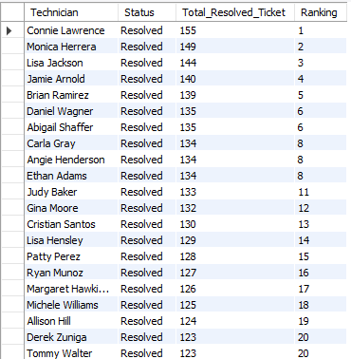

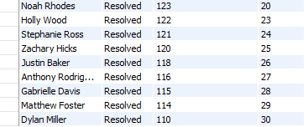

1. Percentage of escalated tickets for each priority level:

select it_ticketing.Priority,count(*) as Total_Tickets,

count(

case when it_ticketing.`Status` = 'Resolved' then 'Finished' end) as Total_Resolved_Tickets,

cast(count(

case when it_ticketing.`Status` = 'Resolved' then 'Finished' end) * 100/count(*) as decimal(10,0))as PCT_Ticket_Resolved from it_ticketing

group by it_ticketing.Priority;

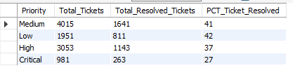

1. Breach rate per month over the year:

select monthname(it_ticketing.Date_Opened) as Ticket_Month,count(*) as Total_Tickets,

count(

case when it_ticketing.Actual_Resolution_Hours > it_ticketing.SLA_Hours then 'Breached' end) as Total_Breached_Ticket,

cast(count(

case when it_ticketing.Actual_Resolution_Hours > it_ticketing.SLA_Hours then 'Breached' end)*100/count(*) as decimal(10,0)) as PCT_Breached_Ticket from it_ticketing

group by monthname(it_ticketing.Date_Opened)

order by PCT_Breached_Ticket desc;

